12. Organic Chemistry - 2

12.1. a) alcohol, 5-methylheptan-3-ol b) aldehyde, 3-ethylpentanal
c) aldehyde. 2,4,4,5-tetramethylhexanal d) carboxylic acid, 2-bromobutanoic acid
e) carboxylic acid, octanoic acid f) carboxylic acid, 2-ethylpentanoic acid
g) ketone, octan-2-one h) ketone, 1-chloro-4-methylpentan-2-one

12.2. | a) | 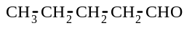 | b) | 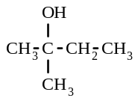 | c) | 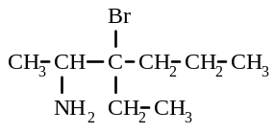
 | d) | 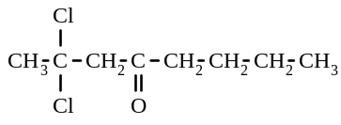 | e) | 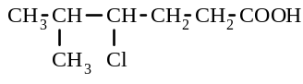

12.3. a) propanal CH₃ - CH₂ - CHO b) pentanoic acid CH₃ - CH₂ - CH₂ - CH₂ - COOH
c) hexan-3-one CH₃ - CH₂ - CO - CH₂ - CH₂ - CH₃ d) no reaction
e) methylpropanoic acid f) pentan-3-one CH₃ - CH₂ - CO - CH₂ - CH₃
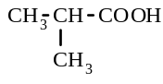

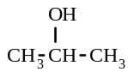
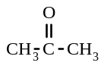
12.4. a)
→ + 2H⁺ + 2e x 5
MnO₄⁻ + 8H⁺ + 5e → Mn²⁺ + 4H₂O x 2

5 + 2MnO₄⁻ + 6H⁺ → 5 + 2 Mn²⁺ + 8 H₂O

b) CH₃ CH₂ CH₂ CH₂ OH → CH₃ CH₂ CH₂ CHO + 2H⁺ + 2e x 3
Cr₂O₇²⁻ + 14H⁺ + 6e → 2Cr³⁺ + 7 H₂O

3 CH₃ CH₂ CH₂ CH₂ OH + Cr₂O₇²⁻ + 8H⁺ → 3 CH₃ CH₂ CH₂ CHO + 2Cr³⁺ + 7 H₂O

c) CH₃ CH₂ CH₂ CH₂ CHO + H₂O → CH₃ CH₂ CH₂ CH₂ COOH + 2H⁺ + 2e x 5
MnO₄⁻ + 8H⁺ + 5e → Mn²⁺ + 4H₂O x 2

5 CH₃ CH₂ CH₂ CH₂CHO + 2MnO₄⁻ + 6H⁺ → 5 CH₃ CH₂ CH₂ CH₂COOH + 2 Mn²⁺ + 3 H₂O
d) no reaction
e) CH₃ CH₂ CH₂OH + H₂O → CH₃ CH₂ COOH + 4H⁺ + 4e x 3
Cr₂O₇²⁻ + 14H⁺ + 6e → 2Cr³⁺ + 7 H₂O x 2

3 CH₃ CH₂ CH₂OH + 2 Cr₂O₇²⁻ + 16H⁺ → 3 CH₃ CH₂ COOH + 4Cr³⁺ + 11 H₂O

12.5. a) CH₃ - CO - O - CH₂ - CH₂ - CH₃ 1-propyl ethanoate
b) CH₃ - CH₂ - CH₃ - CO - O - CH₂ CH₃ ethyl butanoate
c) CH₃ - CH₂ - CH₂ - CO - O - CH₃ methyl butanoate

12.6. a) ethyl pentanoate b) 1-propyl propanoate c) ethyl butanoate d) 1-propyl methanoate

12.7. a) CH₃ - CO - O - CH₂ - CH₂ - CH₃ b) CH₃ CH₂ CH₂ CH₂ CH₂ CO - O - CH₂ CH₃

12.8. a) CH₃ COOH + CH₃OH b) CH₃ - CH₂ - CH₂ - COO⁻ Na⁺ + CH₃ - CH₂ - CH₂OH
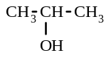
12.9. a) CH₃ - CH₂ - CH₂ OH CH₃ - O - CH₂ - CH₃
propan-1-ol (an ether)
propan-2-ol

12.9 b) CH₃ - CH₂ - CHO CH₃ - CO - CH₃
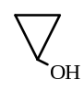
propanal propanone cyclopropanol
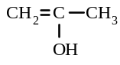
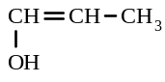
CH₂ = CH - CH₂ OH

1-hydroxyprop-2-ene
2-hydroxyprop-1-ene 1-hydroxyprop-1-ene

c) CH₃ - CH₂ - COOH CH₃ - CO - O - CH₃ HCO - O - CH₂ - CH₃
propanoic acid methyl ethanoate ethyl methanoate
Also, a series of compounds with - one double bond and two alcohol groups
- a three membered ring and two alcohol groups
- one alcohol group and an aldehyde or ketone group

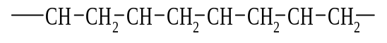
12.10. a) - CCl₂ - CCl₂ - CCl₂ - CCl₂ - CCl₂ - CCl₂ -
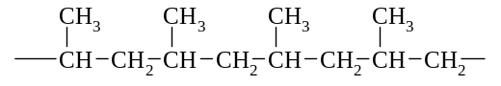
b) c)

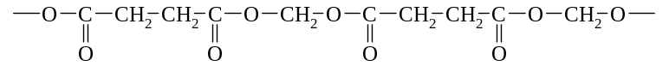
12.11. a)

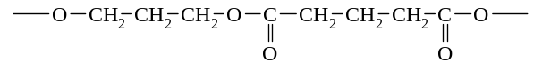
b)

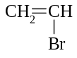
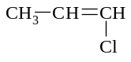
12.12 a) b)

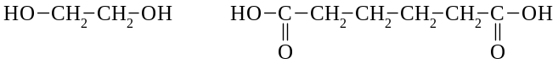
c)

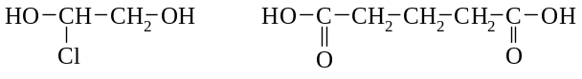
d)

12.13. a) glycerol b) detergent c) fat d) soap e) fatty acid

12.14 a) C₆H₆ b) (benzene)

12.15. a) C₆H₇N b) C₆H₇N c) NH₂

12.16. C₃H₃O

12.17. A 12.18. E 12.19. D
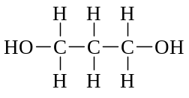
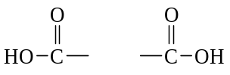

12.20.

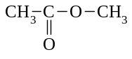
12.21 a) C₃H₆O₂ b) 73.4 c) C₃H₆O₂ d)

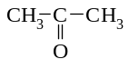
12.22. a ketone: propanone an aldehyde: propanal
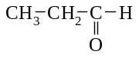

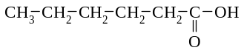
a carboxylic acid: hexanoic acid

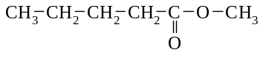
an ester: methyl pentanoate

12.23.
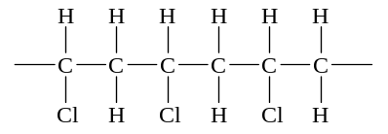

12.24 C₆H₈O₇ 12.25. B 12.26. E

12.27. a) CH₃COOH + CH₃OH → CH₃COOCH₃ + H₂O - sweet smelling odour produced, mixture remains colourless
b) CH₃COO⁻(aq) + H⁺(aq) → CH₃COOH(aq) - solution remains colourless, vinegar-smelling odour produced.

12.28. a) sulfuric acid b) oxalic acid c) benzoic acid d) tetrahydroxozincate ion
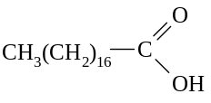
12.29.

12.30. Oxidation half-equation CH₃CHOHCH₃ → CH₃COCH₃ + 2H⁺ + 2e
Reduction half-equation Cr₂O₇²⁻ + 14H⁺ + 6e → 2Cr³⁺ + 7H₂O
Redox equation Cr₂O₇²⁻ + 8H⁺ + 3CH₃CHOHCH₃ → 2Cr³⁺ + 7H₂O + 3CH₃COCH₃

12.31.
 | Your chemical test. Describe fully | What you would observe in each case
Cu(NO₃)₂ | Dissolve both in water, add a solution of barium | with Cu(NO₃)₂ - no precipitate forms
and  CuSO₄ | nitrate to each | with CuSO₄ - precipitate forms
MgCl₂ | Dissolve both in water, then slowly add a solution | with MgCl₂ - a white precipitate forms
and  ZnCl₂ | of sodium hydroxide to each | with ZnCl₂ - a white precipitate forms, but it then dissolves when excess NaOH is added.
CH₃CH₂OH | Test both with moist blue litmus paper | with CH₃CH₂OH - litmus not affected
and  CH₃COOH |  | with CH₃COOH - litmus turns red

12.32. Oxidation half-equation CH₃CHO + H₂O → CH₃COOH + 2H⁺ + 2e
Reduction half-equation Cr₂O₇²⁻ + 14H⁺ + 6e → 2Cr³⁺ + 7H₂O
Redox equation Cr₂O₇²⁻ + 8H⁺ + 3CH₃CHO → 2Cr³⁺ + 4H₂O + 3CH₃COOH
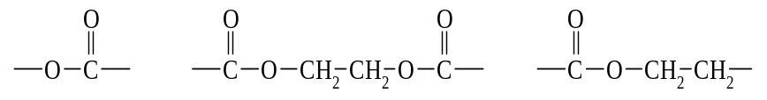
12.33.

12.34. a) 4-methylhexanal b) ethyl propanoate c) butanal d) 1-propyl methanoate
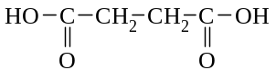
12.35. a) HO - CH₂ - CH₂ - OH b) condensation c) H₂O

12.36. a) C : H = 90.49/12.01 : 9.48/1.008 = 7.53 : 9.40 = 1 : 1.25 = 4 : 5
i.e. the empirical formula is C₄H₅
b) Hydrocarbons have an even number of hydrogens (or there would be an uneven number of electrons in this molecule)

12.36. c) molecular formula = n x empirical formula i.e. n = 105/53 ≈ 2
so molecular formula = C₈H₁₀

d)
CH₂CH₃
CH₃
CH₃
CH₃
CH₃
CH₃
CH₃

12.37. B 12.38. C 12.39. E 12.40. A 12.41. D

12.42. a) i) B ii) A iii) C
b) i) detergents
ii) When a detergent is added to washing water, the detergent ions (surfactant molecules) surround the grease and oil with the non-polar "tails" attached to the grease, and the polar ends left exposed to the water. With agitation, small grease blobs surrounded by detergent ions are produced. These blobs are able to mix, and possibly dissolve in the water because they act as polar substances (due to the polar ends of the ions projecting from them). Thus, the grease can be rinsed away.
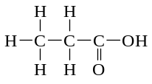

12.43. a) It is a carboxylic acid containing 3 C atoms i.e. name: propanoic acid

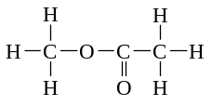

b) name: methyl ethanoate

12.44. Substance A: ethyl ethanoate Substance B: sodium ethanoate
Substance C: ethanol Substance D: ethanoic acid
12.45 D 12.46 A 12.47 D 12.48 C 12.49 A
12.50 B 12.51 A 12.52 A 12.53 A 12.54 D
12.55 D 12.56 C 12.57 A 12.58 D 12.59 A
12.60 B 12.61 C 12.62 D 12.63 D 12.64 E
12.65 D 12.66 D 12.67 A 12.68 A 12.69 B
12.70 D 12.71 E 12.72 C 12.73 B 12.74 A
12.75 B 12.76 B 12.77 C 12.78 B 12.79 D
12.80 A 12.81 D 12.82 C 12.83 E 12.84 D
12.85 D 12.86 E 12.87 E 12.88 E 12.89 C
12.90 C
12.91. a) 7-bromo-4-ethyloctanal b) 5-methylheptan-2-one c) 5,5-dimethylheptanoic acid d) ethyl propanoate e) methyl pentanoate f) 2-methylhexanoic acid
g) propyl pentanoate h) 1-chloro-6-hydroxyoctan-4-one i) methyl ethanoate
j) 4-aminobutanal k) 3-ethylcyclohexanone l) cyclopentyl ethanoate
m) sodium ethanoate n) magnesium propanoate
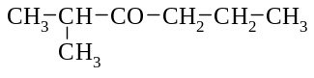
12.92. a) CH₃ - CH₂ - CH₂ - CH₂ - CO OH b) ClCH₂ - CH₂ - CHO c)

d) CH₃ - CO - O⁻ K⁺ or KCH₃COO e) CH₃ - CH₂ - CO - O - CH₃ f) H - CO - O - CH₂ - CH₂ - CH₃
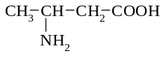
g) h) HO CH₂ - CH₂ - CH₂ OH i) Cl CH = CH Cl

j) CH₃ - CO - O - CH₂ - CH₂ - CH₂ - CH₃

12.93. a) CH₃ - CO - O - CH₃ b) CH₃ - CO - CH₃
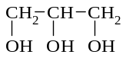
c) a tertiary alcohol cannot be oxidised d) + CH₃ (CH₂)₁₆ COO⁻ (+ Na⁺ or K⁺)

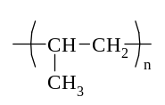
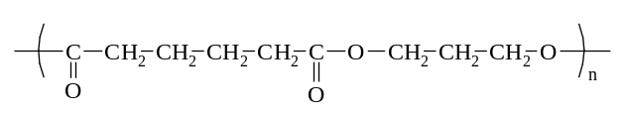

e) f)

g) CH₃ - CH₂ - CH₂ OH + CH₃ - CH₂ - CH₂ - COOH

12.94. Soap as a cleaning agent
A soap is often described as a surfactant. Its function is to assist water to remove grease , oil , dirt and other water-insoluble materials that adhere to surfaces.
To understand the cleaning process, the nature of the surfactant needs to be examined. The surfactant is a large ion consisting of a negatively charged end and an uncharged, non -polar end. Polar or charged particles tend to dissolve in polar solvents, whereas non-polar substances tend to dissolve in non-polar solvents. Water is a polar solvent which can form hydrogen bonds with the charged end of the surfactant. This charged end is known as the hydrophilic or "water-loving" end of the surfactant. As a result, this end of the surfactant ion tends to dissolve readily in water.
On the other hand, the other non- polar end tends not to dissolve in water. However, this hydrophobic or "water-hating" end of the ion can readily mix with non - polar dirt, grease or oil Hence the non- polar hydrocarbon end of the surfactant attaches to the non- polar grease or oil while the charged end is hydrogen bonded to the water molecules.
When the water is agitated, the oil and grease are removed from the surface being cleaned because they are attached by dispersion forces to the hydrophobic end of the surfactant ion. The grease tends to be surrounded by spherical aggregates of surfactant ions whose polar "heads" are directed towards the water and the non- polar "tails" are attached to the grease.

12.95. a) 5 CH₃ CH₂ CH₂ OH + 4MnO₄⁻ + 12 H⁺ → 5 CH₃ CH₂ COOH + 4Mn²⁺ + 11H₂O
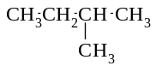
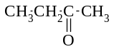
b) 3 + 8H⁺ + Cr₂O₇²⁻ → 3 + 2Cr³⁺ + 7H₂O

c) CH₃ COOH + OH ⁻ → CH₃ COO ⁻ + H₂O
d) CH₃ CH₂ OOC CH₂ CH₃ + OH⁻ → CH₃ CH₂ OH + CH₃ CH₂ COO⁻
e) CH₃ OH + CH₃ COOH → CH₃ OOC CH₃ + H₂O
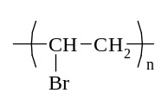
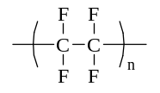
12.96. a) poly(bromoethene) b) poly(tetrafluoroethene)

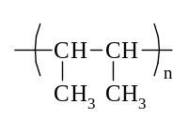

c) poly(but-2-ene)

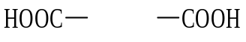
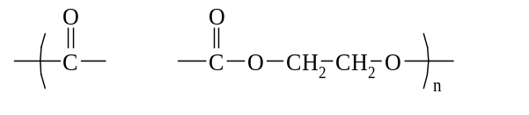
12.97. a) n + n HO CH₂ CH₂ OH

+ n H₂O

b) n HO - (CH₂)₄ - COOH + n HO - (CH₂)₄ - COOH ( O - (CH₂)₄ - CO - O - (CH₂)₄ - CO )_{n} + n H2O

12.98. a) CH₂ = CH₂ b) HOOC - (CH₂)₆ - COOH + HO - (CH₂)₃ - OH

c) CH₂ = CH - d) HOOC - - COOH + HO - (CH₂)₂ - OH

Cl
e) CH₂ = CH Cl

12.99. a) CH₂ b) 56, C₄H₈
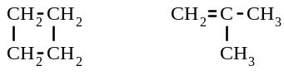
c) CH₂ = CH - CH₂ - CH₃ CH₃ - CH = CH - CH₃

d) CH₃ - CH = CH - CH₃

12.100. a) C₂H₆O b) 46, C₂H₆O c) CH₃ - CH₂ OH

12.101. a) CH₃O b) 62.0, C₂H₆O₂ c) HO - CH - CH₃ HO - CH₂ - CH₂ - OH
|
OH

12.102. a) C₃H₉N b) 59, C₃H₉N c) CH₂ - CH₂ - CH₃ CH₃ - CH - CH₃
| |
NH₂ NH₂

12.103. a) C₃H₂Cl b) C₆H₄Cl₂ c)
Cl
Cl
Cl
Cl
Cl

Cl

12.104. a) C₄H₁₀O b) C₄H₁₀O

CH₃
|
c) HO - CH₂ - CH₂ - CH₂ - CH₃ CH₃ - CH - CH₂ - CH₃ CH₂ - CH - CH₃ CH₃ - C - CH₃
| | | |
OH OH CH₃ OH
d) CH₃
|
CH₃ C CH₃
|
OH

12.105 | 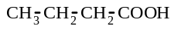 | 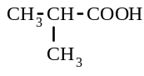 | 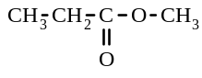 | 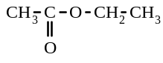
butanoic acid methylpropanoic acid methyl propanoate ethyl ethanoate

12.106 | CH₃ - CH₂ - CH₂ - CHO | CH₃ - CO - CH₂ - CH₃
butanal butanone

12.107 a) i) carboxylic acid ii) ketone iii) primary alcohol iv) secondary alcohol
v) aldehyde vi) ester vii) secondary alcohol viii) tertiary alcohol
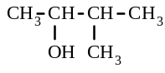
b) i) pentan-1-ol. CH₃ - CH₂ - CH₂ - CH₂ - CH₂ - OH ii) 3-methylbutan-2-ol

12.108 a) HC ≡ CH + HCl → CH₂ = CHCl b) addition reaction
c) n CH₂ = CHCl → ( CH₂ - CHCl )_{n} d) addition polymerisation reaction
H C C H
H H

H C H
O

Cl
H C H
Cl

12.109 a) b) c) d)
H C C Cl
H H

12.110 a) air, sulfur b) hydrogen, nitrogen c) animal fat, sodium hydroxide d) cryolite, bauxite

12.111 | IUPAC name | Structural formula
 | a) 2-chlorohexan-1-ol | 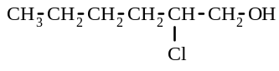
 | b) methyl propanoate | CH₃ - CH₂ - CO - O - CH₃
 | c) but-1-ene | CH₃ - CH₂ - CH = CH₂
 | d) pentan-2-one | CH₃ - CH₂ - CH₂ - CO - CH₃

12.112 a) CH₃ - CHBr - CH₂Br b) CH₃ - COOH c) CCl₃ - CCl₃ d) CH₃OH (or CH₃ - COONa)
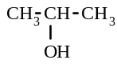
12.113 a) i) ii) CH₃ - CH₂ - O - CH₃

b) A: propanal CH₃ - CH₂ - CHO B: propanoic acid CH₃ - CH₂ - COOH

12.114 a) propanone CH₃ - CO - CH₃ b) 1,2-dibromopropane CH₃ - CHBr - CH₂ Br
c) ethyl propanoate CH₃ - CH₂ - CO - O - CH₂ - CH₃

12.115 a) (1) methyl propanoate (2) butanoic acid
b) (3) CH₃ - CO - O - CH₂ - CH₃ c) 1-propyl methanoate H - CO - O - CH₂ - CH₂ - CH₃
(or 2-propyl methanoate, or methylpropanoic acid)

12.116 | a) | 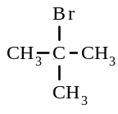 | b) | CH₃ - CO - O - CH₃ | c) | 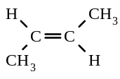

12.117. CH₃CH₂OH + H₂O → CH₃COOH + 4H⁺ + 4e Cr₂O₇²⁻ + 14H⁺ + 6e → 2Cr³⁺ + 7H₂O
Overall redox equation 2Cr₂O₇²⁻ + 16H⁺ + 3CH₃CH₂OH → 4Cr³⁺ + 11H₂O + 3CH₃COOH

12.118 a) propan-2-ol b) butanone

12.119 a) CH₃ - CH₂OH + CH₃ - CH₂ - CH₂ - COOH → CH₃ - CH₂ - CH₂ - CO - O - CH₂ - CH₃
b) CH₂ = CH₂ + HCl → CH₂Cl - CH₃

12.120 Acidified potassium permanganate solution - with the first substance, the purple colour would become colourless, with the second substance, no reaction would occur i.e. the purple colour would remain

12.121 a) H - CO - O - CH₃ b) methyl methanoate c) ethanoic acid

12.122 Oxidation half-equation CH₃ CH₂ CHO + H₂O → CH₃ CH₂ COOH + 2H⁺ + 2e
Reduction half-equation Cr₂O₇²⁻ + 14H⁺ + 6e → 2Cr³⁺ + 7H₂O
Redox equation Cr₂O₇²⁻ + 8H⁺ + 3CH₃ CH₂ CHO → 2Cr³⁺ + 4H₂O + 3CH₃ CH₂ COOH

12.123 a) b) + C₁₇H₃₅COONa
H₂C - OOCC₁₇H₃₅
HC - OOCC₁₇H₃₅
H₂C - OOCC₁₇H₃₅

H₂C - OH
HC - OH
H₂C - OH

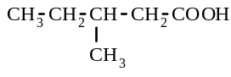
12.124 a) - CH₂ - CH₃ b) c) CH₃ - CH₂ - CHO

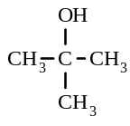
d) e) f) CH₃ - CH₂ - CO - O - CH₃
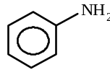

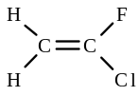
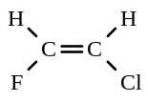
12.125 a) trans-1-chloro-2-fluoroethene b) c)

d) - CHF - CHCl - CHF - CHCl - CHF - CHCl - e) - CH₂ - CClF - CH₂ - CClF - CH₂ - CClF -

12.126 C₃H₂ NO₂
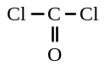
12.127 a) CCl₂O b) 98.9. CCl₂O c)
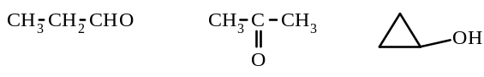
12.128 a) C₃H₆O b) 57.92, C₃H₆O c)

12.129 a) C₂H₄O b) C₄H₈O₂ c)
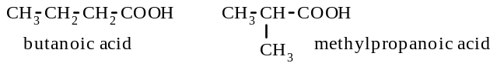

12.130 a) 88.0 b) C₃H₆O c)
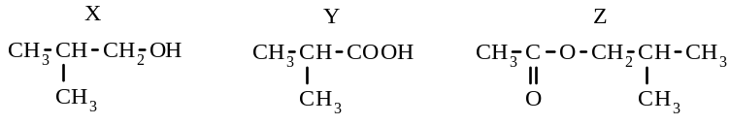

12. Organic Chemistry - 2.

12.21. a) moles of CO₂ = 1.078/44.01 = 0.02449 = moles of C in ‘A’
moles of H₂O = 0.441/18.016 = 0.02448 so, moles of H in ‘A’ = 2 x 0.02448 = 0.0490
mass of C present = 0.02449 x 12.01 = 0.2941 g mass of H present = 1.008 x 0.0490 = 0.04939 g
mass of O present = 0.6047 - (0.2941 + 0.04939) = 0.2612 g
mole of O present in ‘A’ = 0.2612/16.0 = 0.01632
moles ratio = C : H : O = 0.02449 : 0.0490 : 0.01632 = 1.50 : 3.00 : 1 = 3 : 6 : 2
i.e. the empirical formula is C₃H₆O₂

b) PV = nRT n = = 0.001862
molar mass = 0.1367/0.001863 = 73.38 g mol⁻¹ i.e. molecular weight = 73.4
c) molecular formula = n x empirical formula i.e. n = 73.4/74 ≈ 1
so molecular formula = C₃H₆O₂

12.24. moles of CO₂ = 1.110/44.01 = 0.02522 = moles of C in ‘A’
moles of H₂O = 0.303/18.016 = 0.01682 so, moles of H in ‘A’ = 2 x 0.01682 = 0.03364
mass of C present = 0.02522 x 12.01 = 0.3029 g mass of H present = 1.008 x 0.03364 = 0.03391 g
mass of O present = 0.8062 - (0.3029 + 0.03391) = 0.4694 g
mole of O present in ‘A’ = 0.4695/16.0 = 0.02934
moles ratio = C : H : O = 0.02522 : 0.03364 : 0.02934 = 1 : 1.33 : 1.16 = 6 : 7.98 : 6.983
≈ 6 : 8 : 7
i.e. the empirical formula is C₆H₈O₇

12.126. a) In first sample: moles of CO₂ = 2.109/44.01 = 0.04792 = moles of C
moles of H₂O = 0.288/18.016 = 0.01599 so, moles of H = 2 x 0.01599 = 0.03197
mass of C present = 0.04792 x 12.01 = 0.5755 g mass of H present = 1.008 x 0.03197 = 0.03223 g
mass of C in second sample = 0.5775 x 1.061/1.342 = 0.4566 g moles of C = 0.4566/12.01 = 0.03802
mass of H in second sample = 0.03223 x 1.061/1.342 = 0.02548 g moles of H = 0.02548
mole of N in second sample = 0.01263 = moles of N mass of N = 0.01263 x 14.01 = 0.1769 g
mass of O present in second sample = 1.061 - (0.4566 + 0.02548 + 0.1769) = 0.4020 g
mole of O present in second sample = 0.4020/16.0 = 0.02512
moles ratio = C : H : N : O = 0.03802 : 0.02548 : 0.01263 : 0.02512
= 3.01 : 2.017 : 1 : 1.989 = 3 : 2 : 1 : 2
i.e. the empirical formula is C₃H₂ NO₂

12.127 a) moles of CO₂ = 0.970/44.01 = 0.02204 = moles of C
moles of NaOH = 1.04 x 0.0428 = 0.04451 = moles of HCl formed = moles of Cl in compound
mass of C present = 0.02204 x 12.01 = 0.2647 g
mass of Cl present = 0.04451 x 35.45 = 1.578 g
mass of O present = 2.20 - (0.2647 + 1.578) = 0.3573 g
mole of O present = 0.3573/16.0 = 0.02233
moles ratio = C : Cl : O = 0.02204 : 0.04451 : 0.02233 = 1 : 2.020 : 1.013 = 1 : 2 : 1
i.e. the empirical formula is CCl₂O
b) PV = nRT n = = 0.03347
molar mass = 3.31/0.03347 = 98.89 g mol⁻¹ i.e. molecular weight = 98.89
molecular formula = n x empirical formula i.e. n = 98.89/98.91 ≈ 1
so molecular formula = CCl₂O
c)

12.128 a) moles of CO₂ = 0.660/44.01 = 0.0150 = moles of C
moles of H₂O = 0.270/18.016 = 0.01499 so, moles of H = 2 x 0.01499 = 0.02997
mass of C present = 0.0150 x 12.01 = 0.1802 g mass of H present = 1.008 x 0.02997 = 0.03021 g
mass of O present = 0.290 - (0.1802 + 0.03021) = 0.07959 g
mole of O present = 0.07959/16.0 = 0.004974
moles ratio = C : H : O = 0.0150 : 0.02997 : 0.004974 = 3.016 : 6.025 : 1 = 3 : 6 : 1
i.e. the empirical formula is C₃H₆O
b) moles of O₂ = 1.00/32.0 = 0.03125 = moles of vaporised compound
molar mass of vaporised compound = 1.81/0.03125 = 57.92 g mol⁻¹
i.e. molecular weight = 57.92
molecular formula = n x empirical formula i.e. n = 57.92/58.07 ≈ 1
so molecular formula = C₃H₆O

12.129 a) moles of H₂O = 1.113/18.016 = 0.06178 so, moles of H = 2 x 0.06178 = 0.1236
PV = nRT moles of CO₂ = n = = 0.06176 = moles of C
mass of C present = 0.06176 x 12.01 = 0.7417 g
mass of H present = 1.008 x 0.1236 = 0.1246 g
mass of O present = 1.360 - (0.7417 + 0.1246) = 0.4937 g
mole of O present = 0.4937/16.0 = 0.03086
moles ratio = C : H : O = 0.06176 : 0.1236 : 0.03086 = 2.001 : 4.005 : 1 = 2 : 4 : 1
i.e. the empirical formula is C₂H₄O
b) PV = nRT moles of second sample of X = n = = 0.02838
molar mass of X = 2.500/0.02838 = 88.09 mol L⁻¹, i.e. molecular weight = 88.09
molecular formula = n x empirical formula i.e. n = 88.09/44.05 ≈ 2
so molecular formula = C₄H₈O₂

12.130. a) moles of KOH = 0.0108 x 0.0200 = 0.000216 = moles of Y in the 1.0165 g L⁻¹ solution
mass of Y in this solution = 1.0165 x 0.01870 = 0.01901 g
molar mass of Y = 0.01901/0.000216 = 88.00 g mol ⁻¹
i.e. molecular weight of Y = 88.0
b) moles of CO₂ = 0.6532/44.01 = 0.01484 = moles of C in ‘Z’
moles of H₂O = 0.2672/18.016 = 0.01483 so, moles of H in ‘Z’ = 2 x 0.01483 = 0.02966
mass of C present = 0.01484 x 12.01 = 0.1782 g
mass of H present = 1.008 x 0.02966 = 0.02990 g
mass of O present = 0.2870 - (0.1782 + 0.02990) = 0.0789 g
mole of O present in ‘A’ = 0.0789/16.0 = 0.004931
moles ratio = C : H : O = 0.01484 : 0.02966 : 0.004931 = 3.01 : 6.015 : 1 = 3 : 6 : 1
i.e. the empirical formula of Z is C₃H₆O

